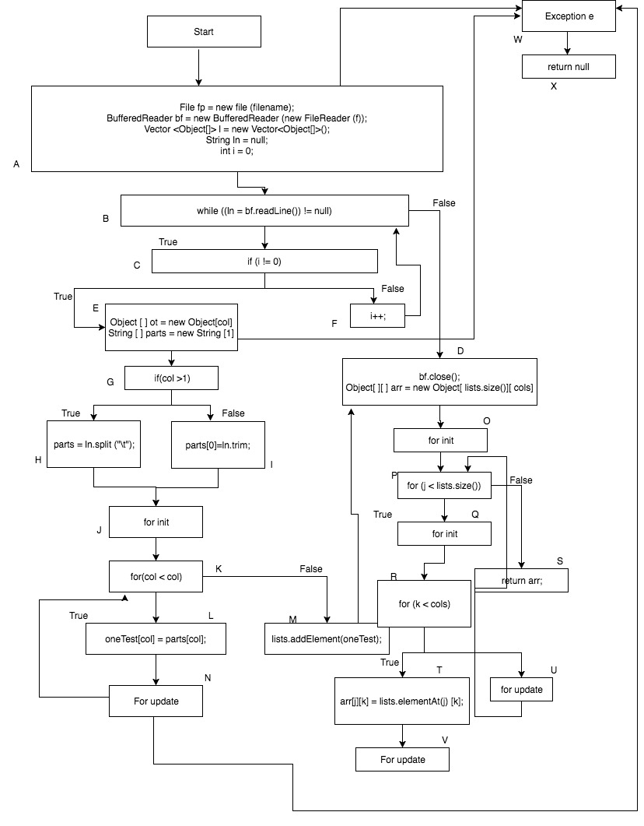

**Paths:**

Path1: A-W-X

Path2: A-B-C-E-G-H-J-K-L-N-N-K-M-D-O-P-S

Path 3: A-B-D-O-P-S

Path 4: A-B-C-E-G-I-J-K-L-N-K-M-D-O-P-Q-R-T-V-T-U-O-P-Q-R-S

Path 5: A-B-C-E-G-H-J-K-L-N-W-X

Path 6: A-B-D-O-P-Q-R-T-V-T-U-P-S

**List Edges:**

A, B, C, D, E, F, G, H, I, J, K, L, M, N, O, P, Q, R, S, T, U, V

Test1: Start from Start and end at return null (A-W-X)

Test2: Start from Start and end at return null (A-W-X)

Test3: Start from Start and end at return null (A-W-X)

Test4:

Start from Start and end at for update (A-B-C-D-E-G-H-I-J-K-L-N-K-M-D-O-P-Q-R-S-T-U-V)

Test5: Start from C and end with S in (C-F-B-D-O-P-S)

Test6: Start from start and end at return arr (A-B-C-F-B-D-O-P-S)

Test7:

Start from start and end at return arr (A-B-C-E-G-I-J-K-L-N-K-M-D-O-P-D)

Test8:

Start from start and end return arr

(A-B-C-E-G-H-J-K-L-N-K-M-D-O-P-Q-R-T-V-T-U-P-R)

Test9: Start from and end return null (A-B-C-E-W-X)

Test10:

Start from and end return arr

(A-B-C-E-G-H-J-L-N-K-M-D-O-P-Q-R-T-V-T-U-P-S)

Test11: Start from start and end at return null (A-W-X)

Test12: Start from start and end at return null (A-W-X)

Test13: Start from start and end at return null (A-W-X)

Test14: Start from start and end at return null (A-W-X)

Test15: Start from start and end at return arr (A-B-D-O-P-S)

Test16: Start from start and ends at return null (A-B-C-E-G-H-I-J-K-L-N-W-X)

Test17:

Start from start and end return arr

(A-B-C-E-G-I-J-K-L-N-K-M-D-O-P-S)

Test18: Start from start and end return arr

(A-B-C-E-G-H-J-K-L-N-K-M-D-O-P-Q-R-T-V-T-U-P-S)